Waimauku to Long Bay College

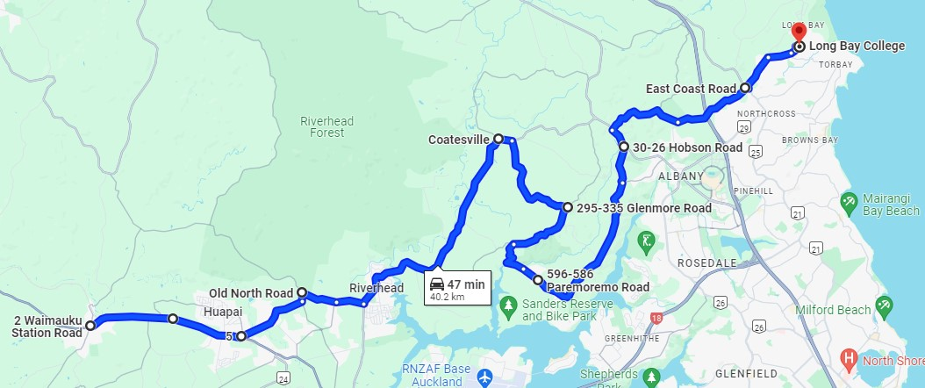

2 Waimauku Station Road
Waimauku 0812
Head southwest on Waimauku Station Rd
At the roundabout, take the 1st exit onto State Hwy 16 heading to Auckland
Turn left onto Oraha Rd
Head northeast on Oraha Rd toward Matua Rd
Turn left onto Old N Rd
Head southeast on Old N Rd toward Deacon Rd
Turn left onto Deacon Rd
Turn left onto Riverhead Rd
At the roundabout, take the 1st exit onto Coatesville Riverhead Hwy/Rte 28 heading to Albany
Turn left onto Sunnyside Rd
Head southeast on Sunnyside Rd toward Coatesville Riverhead Hwy/Rte 28
Turn left onto Coatesville Riverhead Hwy/Rte 28
Turn right onto Glenmore Rd
Head southeast on Glenmore Rd toward Ridge Rd
Turn right onto Ridge Rd
Turn left onto Brookdale Rd
Continue onto Paremoremo Rd
Head southeast on Paremoremo Rd toward Merewhira Rd
Turn left onto Hobson Rd
Lucas Heights, Auckland
Head northwest on Hobson Rd toward Dairy Flat Hwy/Rte 31
Turn left onto Dairy Flat Hwy/Rte 31
Turn right onto Albany Heights Rd
Slight left onto Lonely Track Rd
Turn left onto E Coast Rd
Head southeast on E Coast Rd toward Lonely Track Rd
Turn left onto Glenvar Rd (signs for Baptist Church/Long Bay College)
At the roundabout, take the 2nd exit and stay on Glenvar Rd
Turn left onto Ashley Ave
At the roundabout, take the 1st exit and stay on Ashley Ave
Long Bay College
30 Ashley Avenue, Long Bay, Auckland 0630

